LASMTA MEETING
Date: Wednesday, April 6, 2022
Official Meeting Time: 6:00-7:30 pm
Meeting ID: 819 8303 7939

- Called to Order at 6:05 PM
- Introductions
- Attendance: Juan Rodriguez, Andres Villanueva, Amy Lui, David Lee, Julie West, Mark Johnsen, Michael Turner, Cameron Yassaman, Daniel Gruber, Alexander Waggoner, Eugene Kim, Clemente Sanchez, Claudio Alcantar Barrera, Chris Maurer, James Rozsa, Katie Eikam, Louis Rabaso, Tina Curtis, Scott Martin, Scott Mandel, Gregory Robinson, Darnella Davidson
- Approval of November 2021 Minutes
  - Daniel Gruber motions to approve at 6:18 PM, Michael Turner seconds
- Officer Reports
  - President’s Report
    - Use your AEB monies ASAP
    - Stewart Rupp Scholarship-electronic submission
      - Application due Friday, April 8, 2022
    - Private Lessons Scholarship Auditions
      - Application due April 29, 2022
  - Treasurer Report
    - https://docs.google.com/spreadsheets/d/1Ih0E3QFPWbvhBFN2zJCTyu87B0zdIVpNDktYtaIhXJA/edit
    - David - the funds have gone into the checking account
    - Daniel Gruber motions to approve at 6:20 PM, Cameron Yassaman seconds
  - Secretary Report
    - Amy - number of membership is low 50’s
  - Vice President Report
    - Andres - more mentors than mentees have signed up, everyone has been matched thus far
  - Instagram Account
    - Kelly Anthony started an account - @LA.SMTA
    - Any requests for posts to share about events/recognition - fill out the form under contact us: https://www.lasmta.com/contact-us.html
  - UTLA Liaison
    - James Rosza - provided updates on Ashlie’s behalf
    - 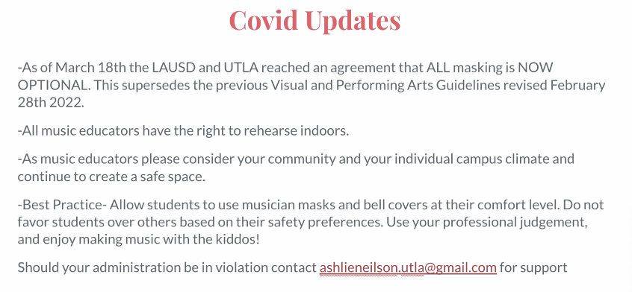
    - 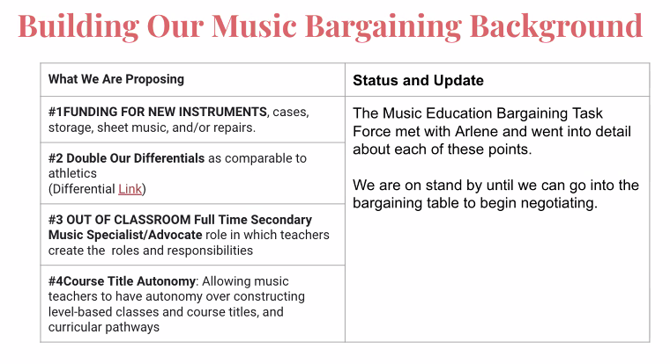
      - Committee had 45 min meeting with Arlene at UTLA to discuss the above
- New Business
  - November ballot measure - Scott Mandel
    - Arts and music education initiative - most likely will win
    - Bringing in $800 million - 80% will go to hiring music teachers, 20% for others
    - Individual schools will determine how the funding will be spent - recommending a council in consultation with the arts dept
    - Campaign email/contact: volunteer@caforartseducation.org
    - Contact Scott: scottmandel@att.net
    - Campaign website: Voteartsandminds.org
    - They need to collect signatures by May and need UTLA music standing committee to approve of it
  - Juan - making LASMTA more effective for 2022-2023 and the future
    - Music Educator’s Handbook - used to be provided to LASMTA members, made by the members with best practices; potentially bringing it back
    - Best Practices Survey - bringing that back, most of recent conversations at meetings was survival; maybe bringing back in-person and include a virtual component
    - Reaching out more to members, do more in-person/online
    - James - making materials/videos/ideas to share and build up over time
    - Mark - have things recorded and archived to review at a later time
    - Amy - now have a connection with CMEA and NAMM, will have a lot more possibilities for LASMTA in providing best practices from across the state for secondary music
    - Beyond the Bell Clinic
  - Open Forum
    - Best Practices
      - David - making it to the middle school concerts and showcasing HS kids to the MS
    - Open Discussion
      - Scott - school got approved by the district to travel out of state to America Sings festival
      - Michael Turner - auditorium refurbishing at SOCES, looking forward to hosting festivals
      - Juan - Snap Raise fundraising and issues with getting school approved for a campaign, Michael and David did it through booster, Scott did it through trust fund with student store to bypass the issue of student body
      - James - recommends HS teachers to send their materials to MS teachers to know the benchmarks/expectations of the next level to properly prepare students through that pipeline
        - Darnella - beware having MS playing HS materials, HS teachers would want to have their own spin on it and wouldn’t want kids to learn it with improper technique and having to unlearn bad habits
- Next Meeting
  - Thursday, May 19, 2022 at 6:00 - 7:30 PM
- Adjournment Meeting adjourned motioned by Daniel Gruber at 7:36 PM and seconded by Darnella Davidson

Minutes respectfully submitted by Amy Lui

