LASMTA MEETING
Date: Tuesday, March 1, 2022
Official Meeting Time: 6:00-7:30 pm
Meeting ID: 819 8303 7939

- Called to Order at 6:04 PM
- Introductions
- Attendance: Juan Rodriguez, Andres Villanueva, Amy Lui, David Lee, Julie West, Mark Johnsen, Ashlie Neilson, Kelly McCarley, Michael Turner, Daniel Gruber, Cameron Yassaman, Karla Boche, Christian Melgoza, Alex Ramirez, Erica Clewett, Colleen Cronin, Darnella Davidson, David Sears, Mariam Kaddoura, Carlos Kuhlmann, Lucas Hermann, Jonathan Cruz, Juan Lebron, Scott Peters, Luis Rabaso, James Rozsa, Scott Mandel, Harry Sierer, Timothy Suits, Edward Vickers, Lori Musicant, Valerie Espinoza, Brian McGaffey
- Approval of November 2021 Minutes
  - Daniel Gruber motions to approve at 6:21 PM, Ashlie Nielsen seconds
- Officer Reports
  - President’s Report
    - Solo and Ensemble Festival postponed due to COVID
    - Stewart Rupp Scholarship-electronic submission
      - Application due Friday, April 8, 2022
      - Julie West - Stewart Rupp background and scholarship is for seniors majoring in music
      - Juan Rodriguez - will be sending out email about applications tomorrow with Friday, April 8 deadline
    - Private Lessons Scholarship Auditions
      - Application due April 29, 2022
      - Private lessons $250 scholarship
        - 2 categories - for students already studying privately and another for training only through school
        - Limited to 5 applicants per LASMTA member
        - Once recipients are selected, winners will be showcased
  - Treasurer Report
    - https://docs.google.com/spreadsheets/d/1Ih0E3QFPWbvhBFN2zJCTyu87B0zdIVpNDktYtaIhXJA/edit
    - David - the funds have gone into the checking account
    - Daniel Gruber motions to approve at 6:33 PM, Scott Mandel seconds
  - Secretary Report
    - Amy - registration still open, people need to also submit a membership form for records of where people teach and what they teach
  - Vice President Report
    - Andres - mentor/mentee program is still open for people who would like to connect
  - Area Representative
    - Kelly - sent out invites to those teaching in East and Central, asked for more people to sign up as area reps for next year (4 reps now but 6 total district areas)
  - UTLA Liaison
    - Sign-in form - used to provide numbers of those engaging in the group
    - Bargaining proposal submissions
      - Need to submit no later than March 11 at 5 PM
      - 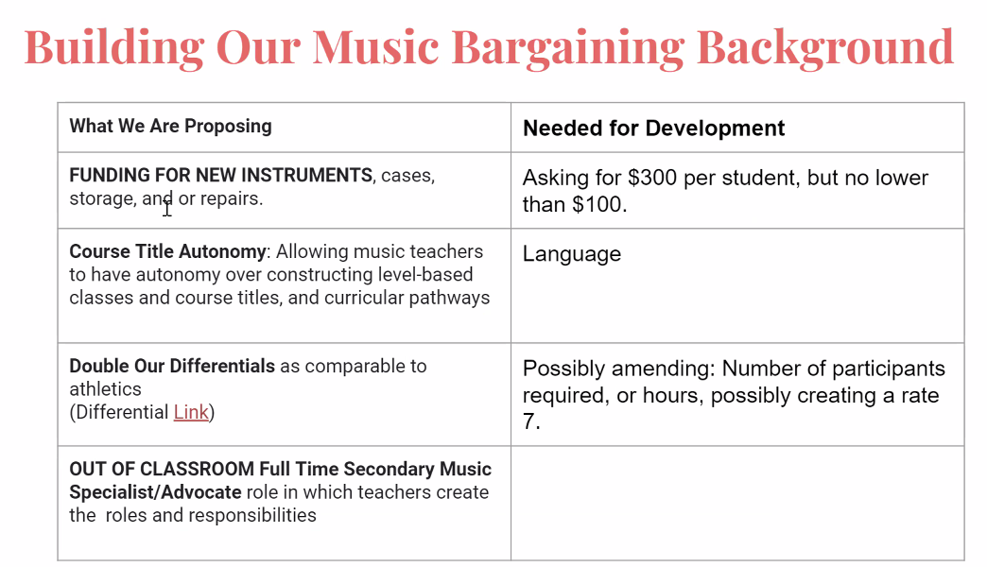
        - Ranking of bargaining proposals via Google form by James Rozsa
      - Ashlie - presentation about updates https://docs.google.com/presentation/d/1Jb_n0ExIKFXdVVTH-fe4BDfxUilBnZhmUELhGi2LfZ4/edit#slide=id.p
      - Ashlie - “Guidelines for Supplemental Assignment Differentials” try talking to principal of the rates and specificities, hoping to double rates like how athletics did https://achieve.lausd.net/cms/lib/CA01000043/Centricity/Domain/161/Differential%20Bul%203856.pdf
      - James Rozsa - provided proposed amendments to BUL-3856.5… https://docs.google.com/document/d/16_Xf4jpUC8WELSV0W6MfAvMxuMAcBk6sXtjXLYldwtI/edit
        - Timothy Suits - differentials might not get approved because it would affect yearbook, newspaper and other similar groups
- New Business
  - November ballot measure - Scott Mandel
    - Arts and music education initiative - trying to have an LAUSD group in there, need volunteers to get signatures
    - Bringing in $800 million - 80% will go to hiring music teachers, 20% for others
    - Individual schools will determine how the funding will be spent - recommending a council in consultation with the arts dept
    - Campaign email/contact: volunteer@caforartseducation.org
    - Campaign website: Voteartsandminds.org
    - They need to collect signatures by May and need UTLA music standing committee to approve of it
  - Social media
    - Kelley - follow LASMTA on Instagram with this handle @la.smta
      - To start showcasing programs and students
      - Fill out the form to request posting on LASMTA Instagram or send email to kelly.mccarley@lausd.net
  - Mask policies - Scott Mandel
    - Important to allow ensembles to perform without masks
    - Scott - need to email Arlene Inouye and Jeff Good at UTLA to demand that we not require masks for performances
- Next Meeting
  - Wednesday, April 6, 2022 at 6:00 - 7:30 PM
- Adjournment Meeting adjourned motioned by Daniel Gruber at 7:28 PM and seconded by Scott Mandel

Minutes respectfully submitted by Amy Lui

